**Home Assignment**

For this assignment, we will be working on extending the FarToCel application during our in-class sessions. (**7 points**)

1. Expand the application to include conversions from Kelvin to Fahrenheit using the formula:

((kel-273.15) * (9/5) + 32); example, 300.1 Kelvin is equal to 59.0 Fahrenheit.

AT test case and ensure that the newly added function is correct. **(1 point)**

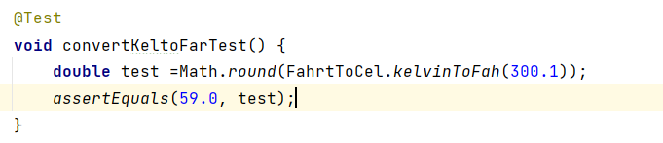

1. If you haven't already done so, create a GitHub repository for FarToCel and push the latest updates to it.

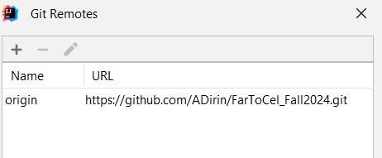 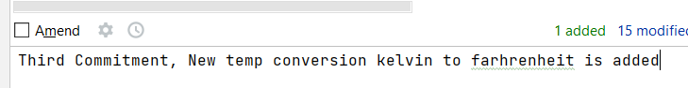

1. Set up a Jenkins project for the FarToCel project (either as freestyle or Maven, *with the name FarToCelKel_pollSCM_Amir*) and configure it to poll the source code repository for changes (* * * * *). Build and make sure everything is ok. **(1-point)**

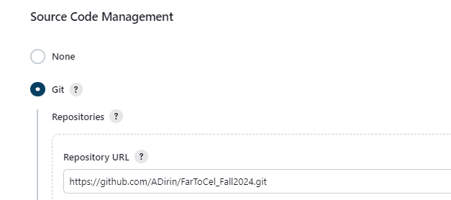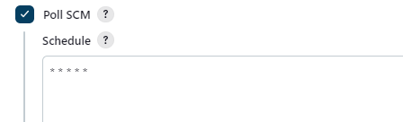

1. Include a *Dockerfile* in the FarToCel project, build it, and run the Docker container locally. **(2 points).** Make sure you add the filename tag and include the package to the manifest in pom.

<**build**>  
 <**finalName**>interconversions</**finalName**>  
 <**plugins**>  
 <**plugin**>  
 <**groupId**>org.apache.maven.plugins</**groupId**>  
 <**artifactId**>maven-jar-plugin</**artifactId**>  
 <**version**>3.2.0</**version**>  
 <**configuration**>  
 <**archive**>  
 <**manifest**>  
 <**mainClass**>org.example.App</**mainClass**>  
 </**manifest**>  
 </**archive**>  
 </**configuration**>  
 </**plugin**>  
 **….**

*# Use an official Maven image as a parent image***FROM** maven:latest  
  
*# Set the working directory in the container***WORKDIR /**app  
  
*# Copy the pom.xml file to the container***COPY** pom.xml **/**app**/***# Copy the entire project to the container***COPY** . **/**app**/***# Package your application***RUN** mvn package  
  
*# Run the main class (assuming your application has a main class)***CMD** [**"java"**, **"-jar"**, **"target/interconversions.jar"**]  
  
  
*# to build: docker build -t javamvn .  
# To run: docker run --name javamvn1 javamvn*

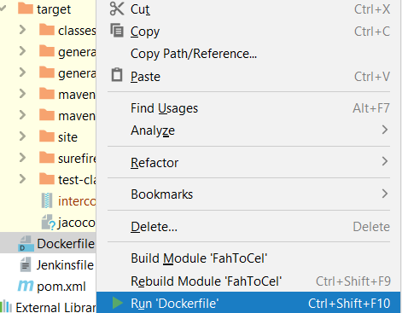 **or** 



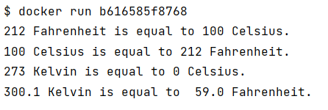

1. Ensure that the latest modifications to your FarToCel project are pushed to GitHub and configure Jenkins to automatically start building after a new commit is uploaded to the repository.

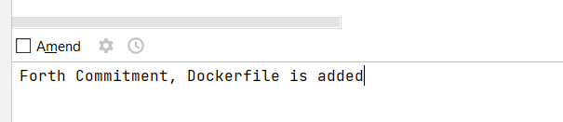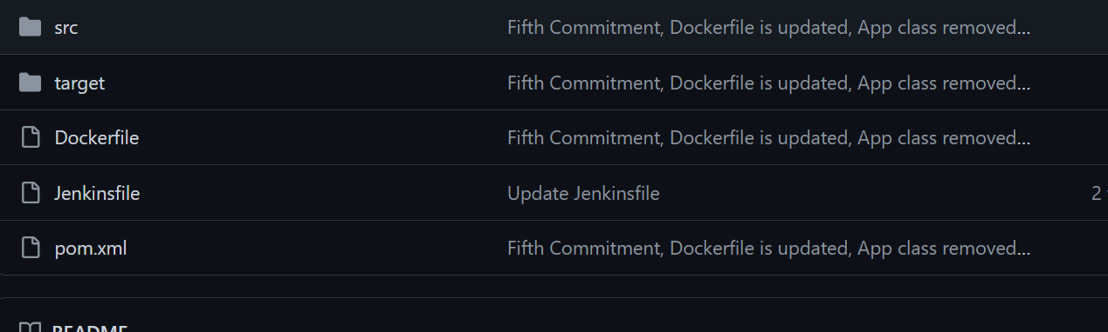

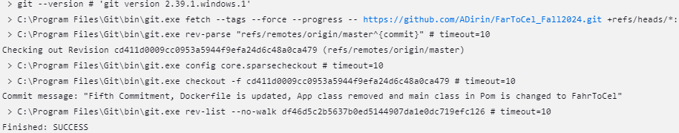

1. Create an account on hub.docker.com if you haven't already. **(1 point)**

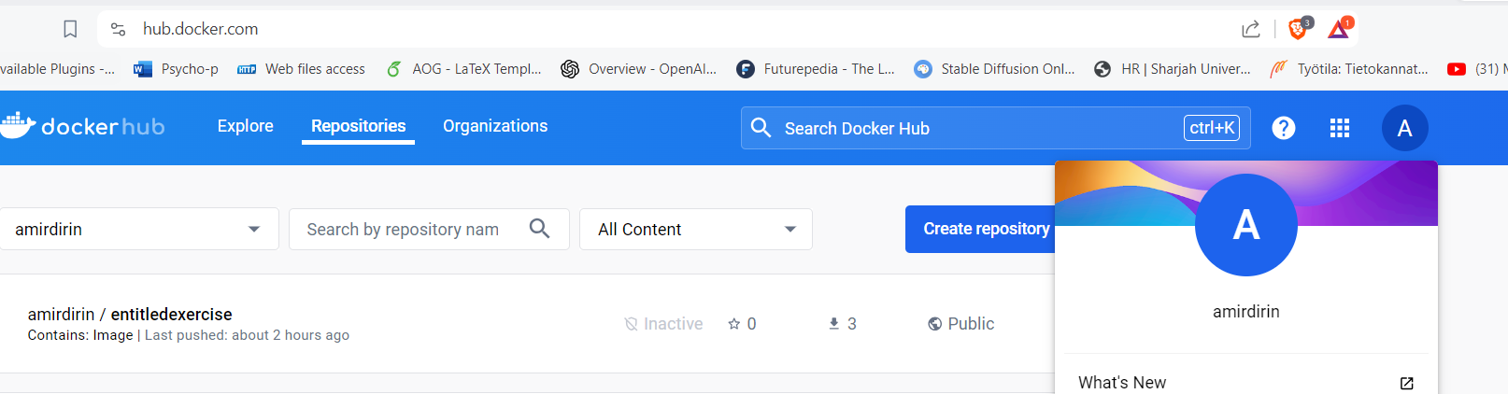

1. Update Jenkins with Docker plugins, referring to the instructions provided in the class and accompanying video clip in the Oma. **(2-points)**

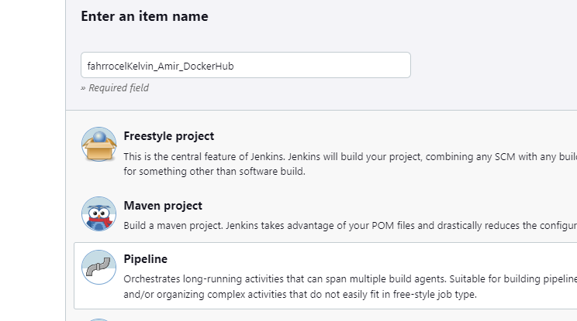

pipeline {

agent any // IN THE LECTURE I WILL EXPLAIN THE SCRIPT AND THE WORKFLOW

environment {

// Define Docker Hub credentials ID

DOCKERHUB_CREDENTIALS_ID = 'amirdirin'

// Define Docker Hub repository name

DOCKERHUB_REPO = 'amirdirin/fartocelkelvin'

// Define Docker image tag

DOCKER_IMAGE_TAG = 'latest'

}

stages {

stage('Checkout') {

steps {

// Checkout code from Git repository

git 'https://github.com/ADirin/FarToCel_Fall2024.git'

}

}

stage('Build Docker Image') {

steps {

// Build Docker image

script {

docker.build("${DOCKERHUB_REPO}:${DOCKER_IMAGE_TAG}")

}

}

}

stage('Push Docker Image to Docker Hub') {

steps {

// Push Docker image to Docker Hub

script {

docker.withRegistry('https://index.docker.io/v1/', DOCKERHUB_CREDENTIALS_ID) {

docker.image("${DOCKERHUB_REPO}:${DOCKER_IMAGE_TAG}").push()

}

}

}

}

}

}

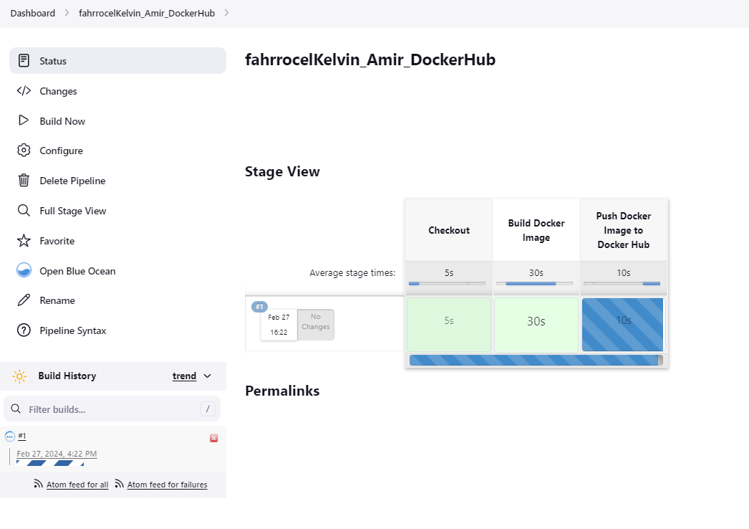

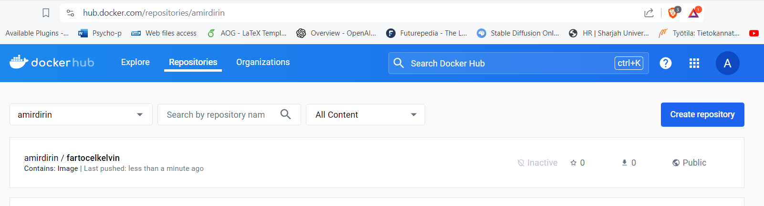

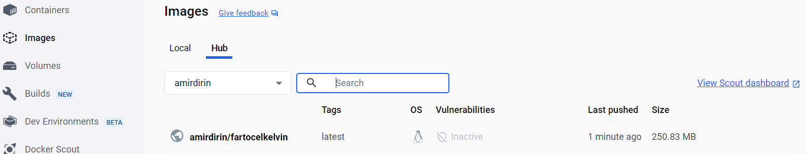

Provide the link to your GitHub repository, screenshots of your Docker Hub repository, and Jenkins build reports as part of your submission.